Jenkins

1)Launching an Ec2 machine

Go to ec2 -> instances -> launch machine

Select Microsoft windows server 2019

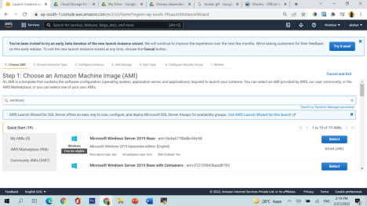Select t2.micro

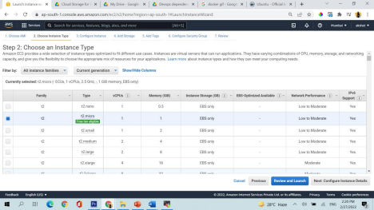No changes in configure instances

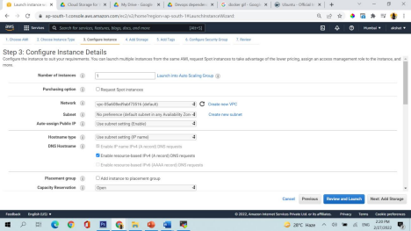No changes in add storage page

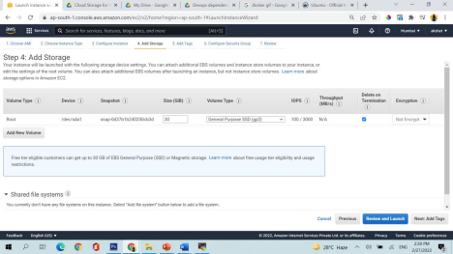In security group add http and custom tcp (with port range 8080) make sure source is anywhere. Refer the below image

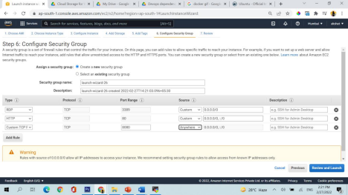

Now review and launch and then launch the machine. It will ask you to create the keypair. Create a keypair

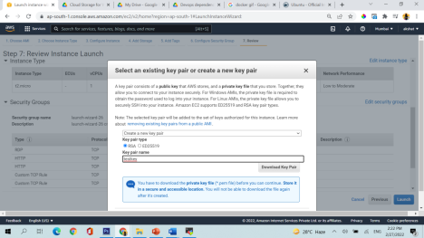My instance is getting launched

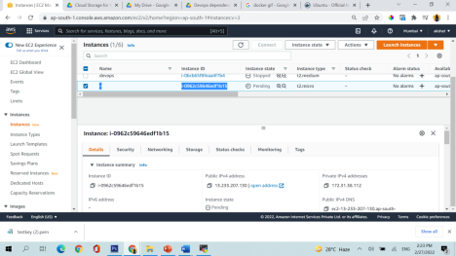2) Now lets connect to the instance

Go to mobaxterm software

(https://drive.google.com/file/d/1y

kG7FmY55jaDYa4IbrHbzSLlSHNbodG/view?usp=sharing) you can download the software from here

Open the software

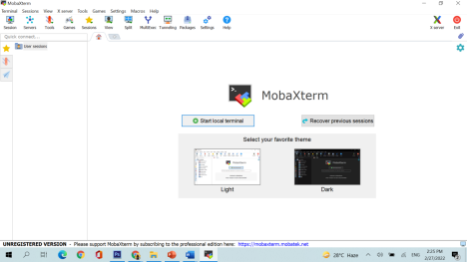

On the top go to sessions and create a new session and after that click on rdp when pop up will come

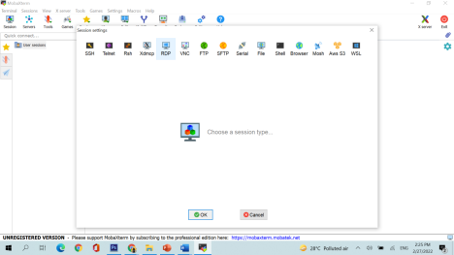

Here put remote ip (which is public ip of the machine) and username administrator

And password you will get when you select your machine in aws console and go to rdp client and click to get the password

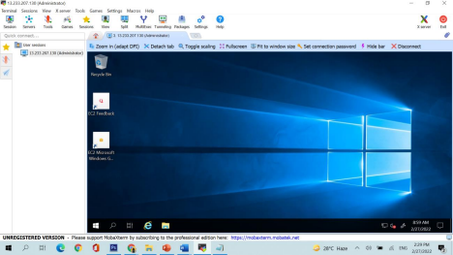

(Still confused? You can connect via RDP too : Here is link to check the video for the same: https://www.youtube.com/watch?v=cFeoZOzV2Xc)

Lets see another method to connect with our windows RDS machine as well

Download this remote desktop file and when you click on password it will ask you to paste the keypair there. Do that the password will be displayed after that

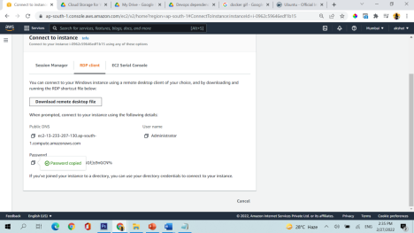Paste your password

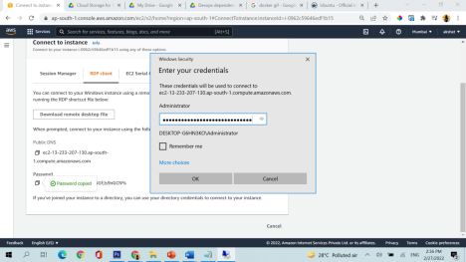Viola entered inside the machine

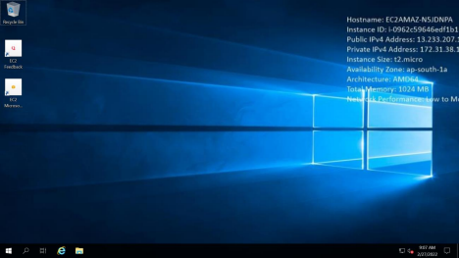

3) Go inside the server

Click on server manager -> click on local server -> IE enhanced security -> Disable

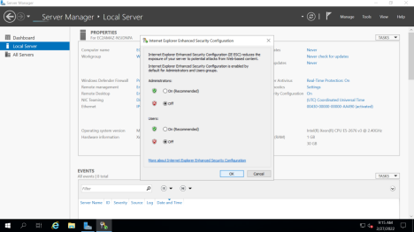

4) Go to internet explorer and open https://git-scm.com/downloads And download git for windows

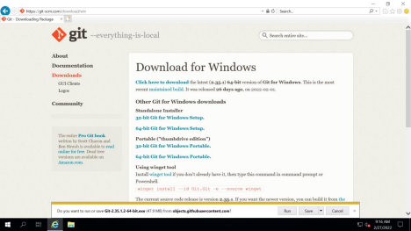

You can download the software and then install it by clicking on next -> next -> next -> next …and so on



5) Now download java 11

https://www.oracle.com/in/java/technologies/javase/jdk11-archive downloads.html

Download this x64 installer

Create an account on oracle website

Java 11 would be downloaded

Now we need to install the software

Click on next next next./..///

6) Now we need to download maven

https://maven.apache.org/download.cgi?Preferred=ftp://ftp.osuosl.org/pu b/apache/

in this download binary zip archive

Now it will open like this

Now copy this folder and paste it in C drive





7) Now download Jenkins

https://www.jenkins.io/download/

Click on the windows written on the above screen

Jenkins will start installing

8) Now lets go and add environment variables

Copy the java path : C:\Program Files\Java\jdk-11.0.13

Go to startup menu at the bottom and search for enviroment variables

Click on enviroment variables



Click on new on user variables

Add name and path like image below



For system variables also do the same thing



Double click on PATH -> click on new



Paste the bin folder link of java like: C:\Program Files\Java\jdk-11.0.13\bin

Now lets add maven environment variables

Add new user variables and system variables as above…but link this time would be of maven

C:\apache-maven-3.8.4





Double click on path in system variables -> (new)add bin folder link of maven

9) Now lets go back to jenkins

Click on localhost link

Jenkins is now succesfully configured

